Development testing

Here I will be showing a like story of how I built the project. I will explain errors encountered with each objective if there are any. And how I solved the issue.

Below are objectives where I had issues building

Objective: 4) Customers should be able to sign up.

**Success criteria:** There should be a form, asking customers to enter their details. Then ask them to create a username and password which, should be saved on the database. Then redirecting them to the login page.

Here I ran into a problem where it was not allowing me to create an account.

I entered 10 digits in the telephone number and it was not letting me to create an account.

Then I looked at the code. And found that the txtTelNo length was set to = 10. Meaning if the textbox has 10 digits it will not let you create the account. Therefore, I changed it to not equal to 10, then displayed the message and not allowed to make the account.

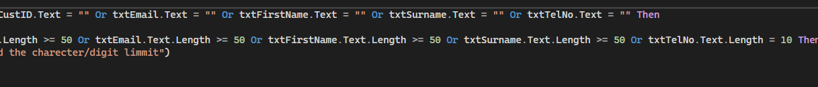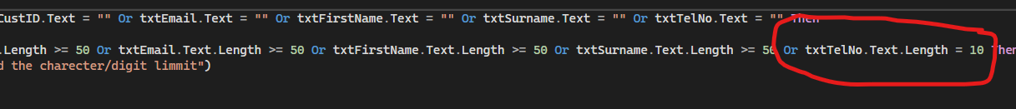

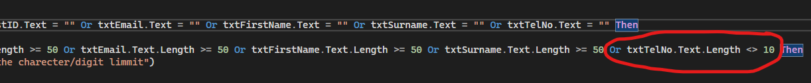

Then I tried making an account and it worked 😊.

Redirected to frmLogIn.

Objective 11) The system should display a brief description of the room with what the room comes with, for example, a coffee machine.

**Success criteria:** Staff members and customers should be able to see a brief description of the room and what it comes with. This also gives a brief idea of what you are paying for. Staff members should be able to add and edit the description.

In this objective, I was trying to display the room description which is stored in the database but it wasent working

Then I took a good look at the database and compared them to the ones in the code.

I found that I have no such thing as RoomID. It was RoomNumberID so I changed it back

And it worked. YAY 😊!!

Objective 14) There should be no collision.

**Success criteria:** Should display the availability of the room, for example, if the room is in use, state that the room is “occupied”.

Here I created an SQL query to display un booked rooms.

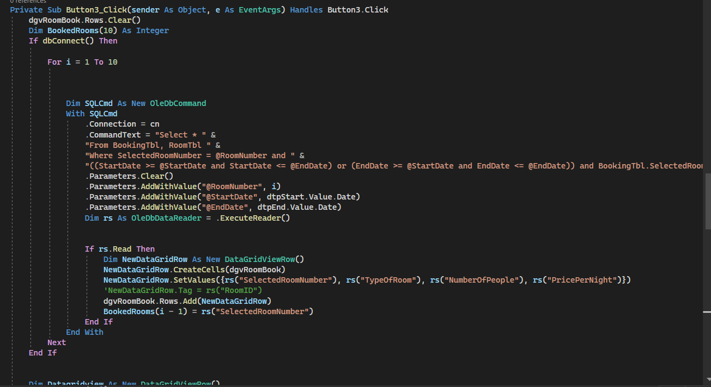

BUT IT SHOWS ONLY BOOKED ROOMS. So then I adapted the SQL as I found out there is a NOT IN procedure. I made it that if the room is booked within the start date and end date DON’T SHOW IT.

After making this change it worked. YAY 😊!

Objective: 15) Should be able to authorize staff to change the availability of the room.

**Success criteria:** Staff members should be able to change the availability of the room, for example, if the room is “occupied” and that person is no longer staying in staff members can change the “occupied” into “available”.

Here I had a problem with displaying room availability. However, it was still showing unavailable rooms.

Then I noticed SQL only considers “and “ and not the “&” symbol. Therefore I changed it.

After making this change it worked. YAY 😊!

THE NEXT PROBLEM I RAN INTO WAS NOT AN OBJECTIVE BUT I DECIDED TO INCLUDE IT. THIS IS BECAUSE TOTAL PAYMENT IS A FUNDAMENTAL FEATURE OF A BOOKING. THEREFORE, I WILL BE INCLUDING IT HERE.

Firstly, I tried to create a new label that contains the sum of the Optional choices. Being label8.

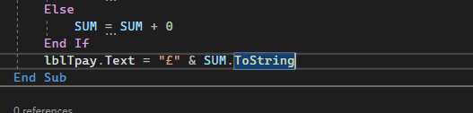

However, it did not add the total price to the total payment. Meaning it didn't add extra choices to the price per night. As seen below.

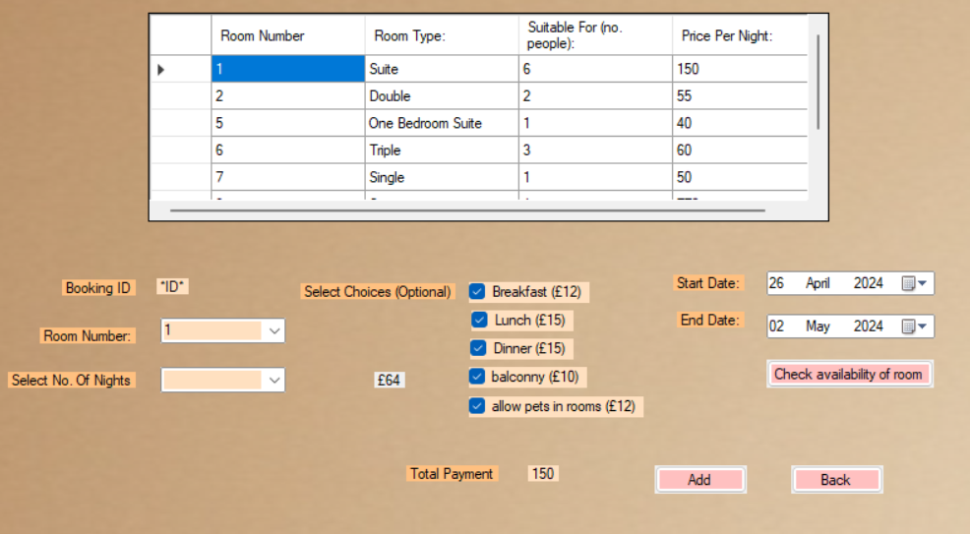

I decided to separate label 8 and lbl tcost because they are separate labels and it will make it a lot easier to solve this problem as label 8 will be stored separately.

Then when the room is selected it will read the price per night and add lbl 8 which constantly can change depending on check boxes.

Adding this change solved my problem. YAY 😊 !!

